

**Project Report On: My Portfolio Website**

**Submitted by:**

**Name: Apon Talukder**

**ID:220311001**

**Department: CSE**

**Date:27 July, 2025**

**Course: Industrial Training**

**Course Code: CSE-410**

**Submitted To**

**Md Ziaur Rahman**

**Department of Head & Assistant Professor Dept. Of CSE, UCTC**

**Mustakim Al Mamun**

**Lecturer,**

**Department Of CSE,UCTC**

**Abstract**

**Area:** This Django-based portfolio project aims to create a dynamic and visually appealing online platform to showcase my web development skills and projects. The platform will provide visitors with a comprehensive overview of my technical abilities, past projects, and contact information. By utilizing Django's robust framework, I will implement features such as user authentication, project display, a contact form, and a blog. The project will prioritize user experience, responsive design, and security best practices to create a professional and engaging online portfolio.

**Importance:** A well-crafted online portfolio is crucial for web developers to showcase their skills and attract potential employers. A Django-powered portfolio offers several advantages Django's elegant framework enables the creation of clean, well-structured, and visually appealing websites. Django incorporates built-in security features to protect against common web vulnerabilities. The large and active Django community provides extensive resources and support.

**Objective:** The primary objective of this project is to develop a functional and visually appealing portfolio website that.

Clearly showcase my proficiency in Python, Django, HTML, CSS, and JavaScript. Present a curated selection of my previous work, including detailed descriptions, screenshots, and live demos. Enable visitors to easily reach out to me with inquiries or job opportunities. Share my insights, tutorials, and experiences through a regularly updated blog.

**Methodology:** Voting System project is developed using Python, HTML, Django, Bootstrap, CSS, Database :- SQLite. The purposed system has been developed using Django and servers also run http://127.0.0.1:8000/. Deploy the project to a web server, such as Heroku, AWS, or DigitalOcean.

Configure the server for optimal performance and security.

**Result:** Upon completion, this project will deliver a robust and user-friendly portfolio website that

Captures the attention of recruiters and hiring managers. Captures the attention of recruiters and hiring managers. Enables easy communication with other professionals. Establishes a strong online presence.

**Introduction**

This report documents the development of a Django-based portfolio website. The primary goal of this project was to create a dynamic and visually appealing platform to showcase my web development skills and projects. By leveraging Django's powerful framework, I aimed to build a robust and scalable website that effectively communicates my abilities to potential employers and clients.

The report will delve into the project's requirements, design considerations, implementation details, and the final outcome. It will also discuss the challenges encountered during development and the strategies employed to overcome them.

I believe that great web development is a blend of technical expertise and artistic flair. I strive tocreate websites that are not only functional but also visually appealing and user-friendly. I'm committed to staying up-to-date with the latest technologies and industry best practices.

**Methodology**

The methodology for developing a Portfolio using Django involves a systematic approach that encompasses various phases of the software development life cycle (SDLC).

**Requirement:**

* HTML
* CSS
* Bootstrap
* Django

**Requirement Gathering**:.

Identified the core features and functionalities required for the portfolio website, including:

1.User authentication and profile management

2.Project showcase with detailed descriptions and live demos

3.Contact form for inquiries

4.Blog section for sharing insights and tutorials

**Technical Stack Selection:**

1.Chose Django as the primary framework due to its robust features, security, and scalability.

2.Selected Python as the programming language for its readability and versatility.

3.Utilized HTML, CSS, and JavaScript for frontend development.

**Database Design:**

1.Created a database schema to store user information, project details, blog posts, and contact messages.

2.Implemented relationships between models to efficiently manage data.

**Development and Implementation:**

**Model Creation:**

1.Defined Django models to represent the database entities.

2.Established relationships between models to facilitate data retrieval and manipulation.

**View Implementation:**

1.Developed views to handle user requests, process form submissions, and render templates.

2.Utilized Django's built-in authentication system for user management

**Results**

When the admin or student accesses the application, they will be greeted by a Contact page,Home Page & About. Upon successful authentication, the user will be directed to the home screen, which serves as the central hub for all operations. From this home screen, users can navigate to various sections to perform different tasks efficiently.

**Contact Page**

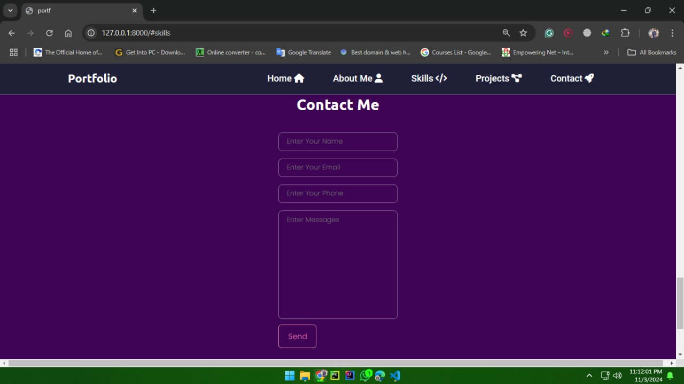

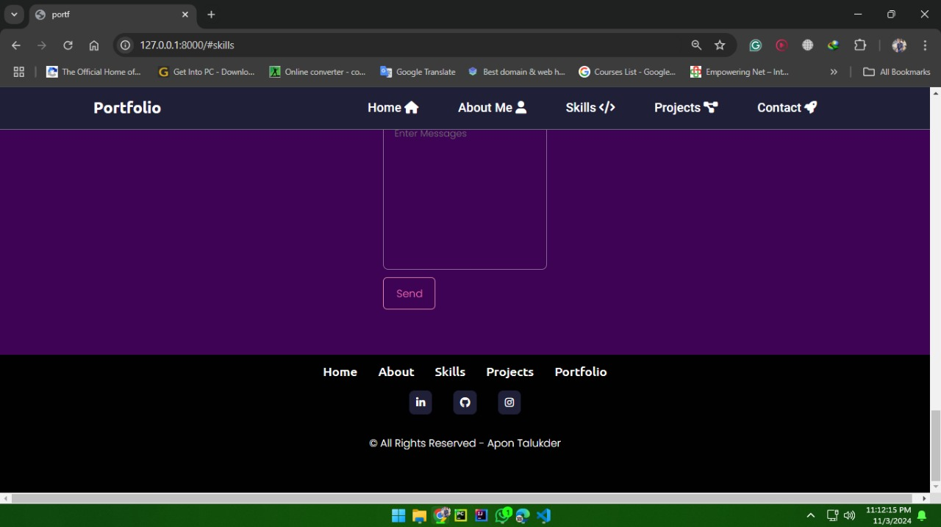

**Home Page:**

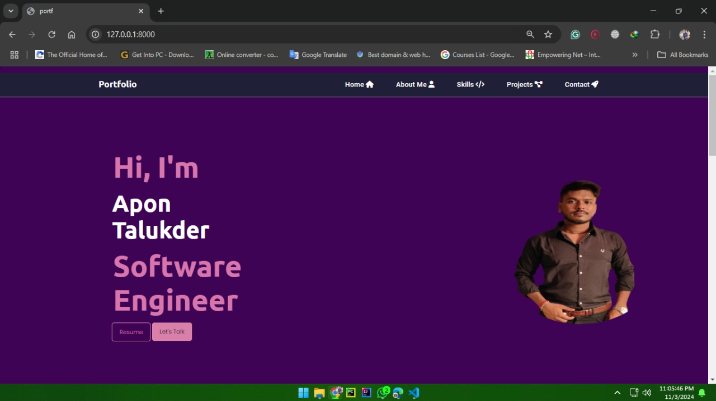

**About:**

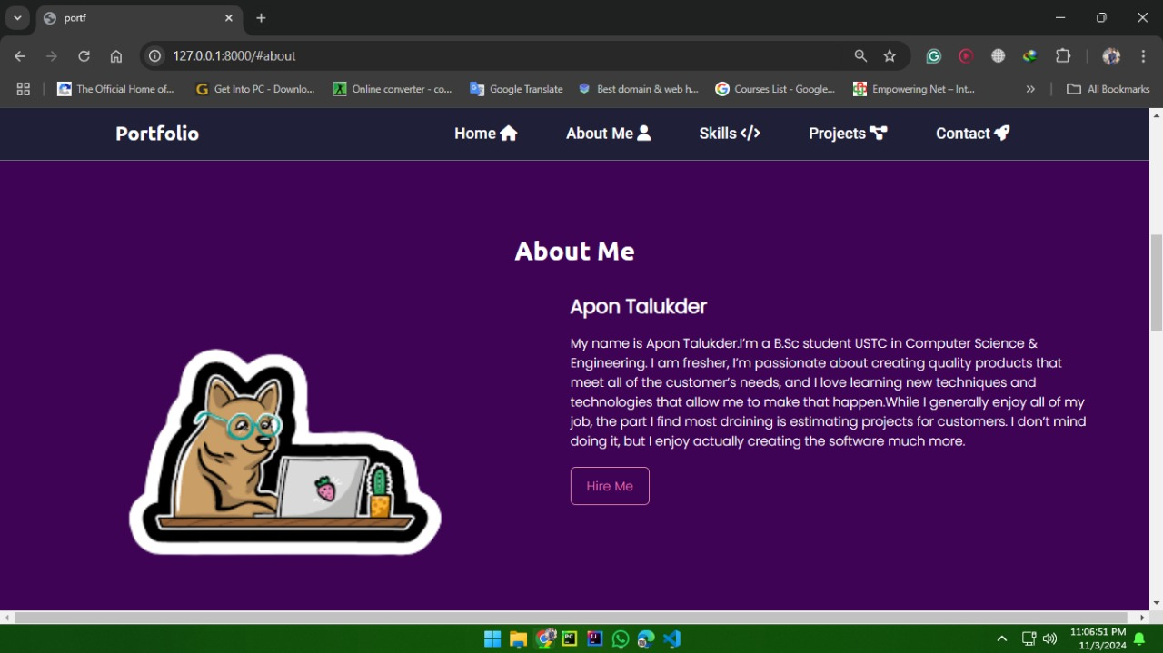

**Conclusion**

The development of this Django-based portfolio website has been a rewarding experience. The project successfully met its primary objective of creating a dynamic and visually appealing platform to showcase my web development skills and past projects. Django's powerful features and extensive community support facilitated efficient development. The website provides a seamless user experience with intuitive navigation and visually appealing design. The project is designed to scale with future growth and accommodate additional features. Strong security measures have been implemented to protect the website and user data. Integrating real-time chat functionality to foster community engagement. Adding an e-commerce section to sell digital products or merchandise. Implementing a more sophisticated search engine to improve user experience.

I am confident that this portfolio website will serve as a valuable tool to showcase my skills and attract potential employers and clients. I will continue to maintain and improve the website, incorporating new technologies and design trends as they emerge.